Data Science and Data Visualization

Lab 4 –D3.js – Transition, Update, Enter & Exit

Reference:
D3: https://d3js.org/
D3 tutorials: https://github.com/d3/d3/wiki/Tutorials
Samples in the Interactive Data Visualization for the Web book:
https://github.com/scotthmurray/d3-book/tree/master/chapter_09

Instructions
- Use ONLY D3 library
- Read chapter 9 of the Interactive Data Visualization for the Web
- Submit your work (all html, js, css files) to the blackboard assignment for this lab
Details
Info
Create an HTML web page with the title “Lab 4”. It contains the following text:
- Your name
- Your student ID
- The course tile “Data science and data visualization”
- The lab title “Lab 4 –D3.js - Transition, Update, Enter & Exit”
- The text “This is all my own work. I did not copy the code from any other source”

Horizontal bar chart
Reference result
https://www.youtube.com/watch?v=wykaDgXoajc
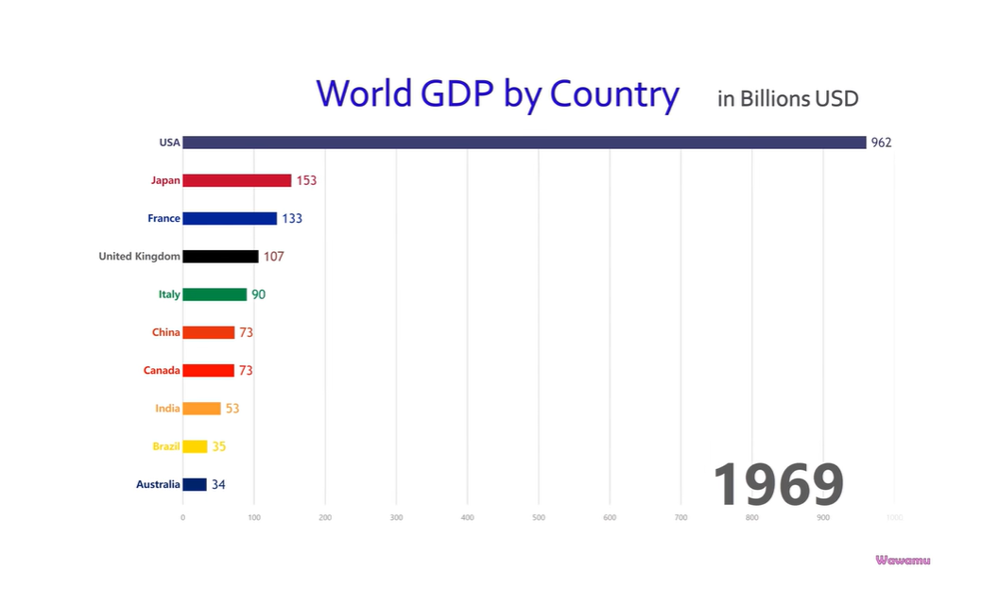
Expected result
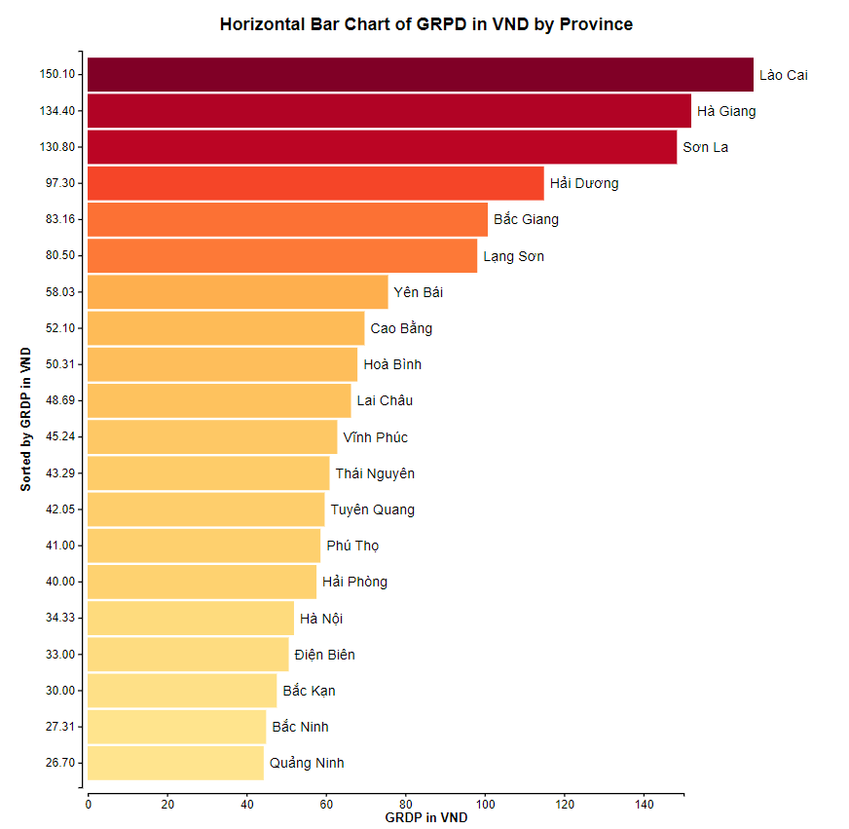
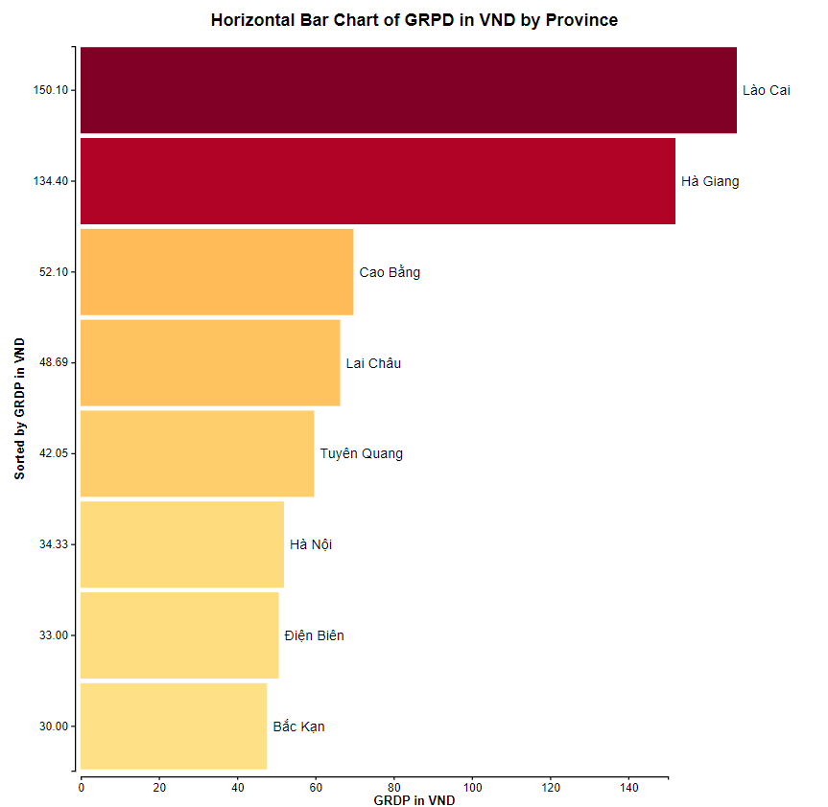

d3.csv("https://tungth.github.io/data/vn-provinces-data.csv", rowConverter)
.then(error, data) {
if (error) {
console.log(error);
}
else {
console.log(data);
// your code to handle the data and draw charts
}
}

- Show the GRPD of 20 first provinces in the data in a horizontal bar chart with label for data on the right of the bar.
- Show axis with label and ticks
- Implement a button to add a new province from the data to the chart. You should update axis and its ticks, the size of each bar.
- Implement a button to remove the last province from the chart. You should update axis and its ticks
- Use transition, duration, on “start”, on “end” to make animation and highlight for changes in the chart
- Implement a combo box to select a criterion for sorting. Whenever the sorting criterion is changed, update the chart with animation
Hint:
- You should bind data to HTML element with a key
- Code to implement a combo box and handle its “on change” event
// HTML code for a combobox
<select id="sort-select">
<option selected value="type">Type</option>
<option value="product">Product</option>
<option value="weight">Weight</option>
</select>
// JS code for an event handler using d3
d3.select("#sort-select").on("change", function (event, d) {
let criterion = event.target.value;
// sorting the array based on name, or GDP
data = data.sort(function (a, b) {
switch (criterion) {
case "name":
// lexicographic sorting for province name
if (a[criterion] < b[criterion])
return -1;
else if (a[criterion] > b[criterion])
return 1;
else return 0;
case "GDP":
// sorting by magnitude of tons
return b.GPD - a.GDP;
}
});
// this execute serves as the update
execute();

